**Two dimensional list in python**

**Kevin Karanja Wachira**

**Naivasha,2023**

**Purpose:**

* to represent multiple data items of same type by using only single name
* To be able to access items in the lists of lists
* To be able to store data in linearly manner that is columns and rows

**Theory:**

Two dimensional array is an array within an array. It is an array of arrays. In this type of array the position of an data element is referred by two indices instead of one. So it represents a table with rows and columns of data.

To process 2-dimensional array, you typically use nested loops. The first loop iterates through the row number, the second loop runs through the elements inside of a row. For example, that's how you display two-dimensional numerical list on the screen line by line, separating the numbers with spaces.

A two-dimensional list can also be used to store objects, which is especially convenient for programming sketches that involve some sort of "grid" or "board."

**Task:**

Determine the number of classes of equivalent columns of the given rectangular matrix. Columns are considered equivalent if the sets of their elements are equal.

**Solution:**

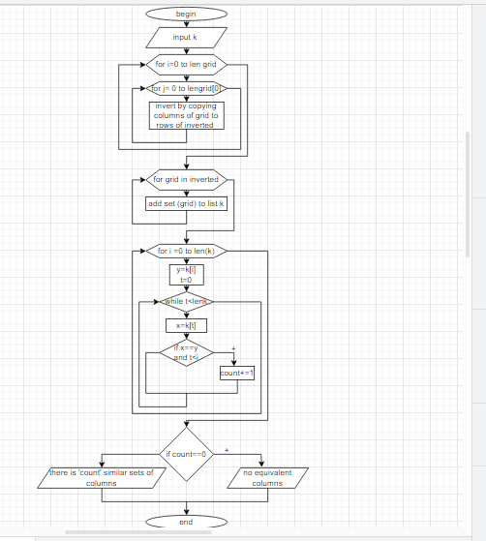

**Code:**

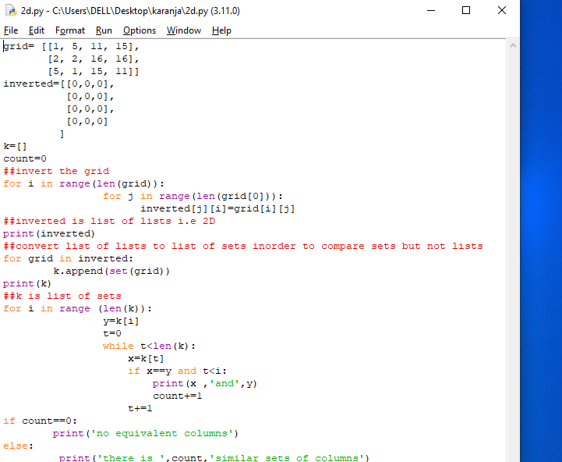

**Conclusion:**

When storing multiple data types e.g lists in python we use multi dimensional list and when accessing specific items we use nested loops.